**WEB ENGINEERING Course Instructor: Razi Ahmad Date: 05-01-2018 LAB 11 JSPSERVLETS**

**Note:**

* Student collaboration is not allowed.
* Copying from or looking at solutions from other sources is strictly prohibited.
* Violations will not be excused and may result in an F in the course.
* Stay honest.

Task 1:

Write a Html page that contains 3 labels and 3 textboxes (Username, password and Expression) user will enter username, password and expression. Username and Password of user will validate from parameter from web.xml (username and password parameter added by you) if the username and password entered by user is corrected than evaluate the expression that it is palindrome or not and show on Html page. Otherwise your servlet will “You have entered wrong username or password”

Example:

On expression aba your servlet will show “This expression aba is palindrome”

On expression abc your servlet will show “This expression aba isn’t palindrome”

Task 2:

Write a program that is going to perform Login Validation. Design an HTML Page that will get username and password from the user. Write a servlet class that will validate password and username and will forward to Welcome Servlet. The Welcome Servlet will display welcome message to the user by displaying his name too. If the password or username is incorrect it will display an error message. Use hardcoded information for username and password.

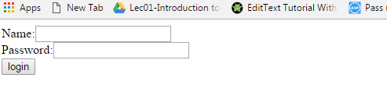

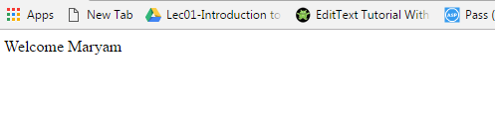

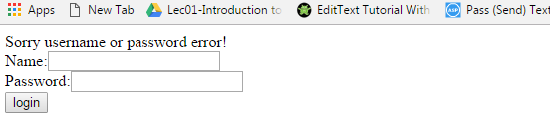

Task3:

Write a program in which client orders for some quantity of a specific good. The request is passed to Order Servlet. Order Servlet class does not have the price of that good so Order Servlet will pass client data to Calculate Servlet class. Calculate Servlet will calculate the amount of bill and will return back to Order Servlet Class. And finally the billing amount will be shown to client.